ONEWAY CS BY HOS
/STATISTICS DESCRIPTIVES HOMOGENEITY WELCH
/PLOT MEANS
/MISSING ANALYSIS.

Oneway

Notes
Output Created |  | 05-May-2019 23:39:59
Comments
Input | Active Dataset | DataSet0
Input | Filter | <none>
Input | Weight | <none>
Input | Split File | <none>
Input | N of Rows in Working Data File | 30
Missing Value Handling | Definition of Missing | User-defined missing values are treated as missing.
Missing Value Handling | Cases Used | Statistics for each analysis are based on cases with no missing data for any variable in the analysis.
Syntax |  | ONEWAY CS BY HOS  /STATISTICS DESCRIPTIVES HOMOGENEITY WELCH  /PLOT MEANS  /MISSING ANALYSIS.
Resources | Processor Time | 00 00:00:00.157
Resources | Elapsed Time | 00 00:00:00.158

[DataSet0]

Descriptives
 | N | Mean | Std. Deviation | Std. Error
Between 7-5 hours of sleep | 8 | 40.0000 | .00000 | .00000
Between 7-9 hours of sleep | 8 | 37.0000 | 4.14039 | 1.46385
Less than 5 hours of sleep | 7 | 37.5714 | 3.04725 | 1.15175
More than 9 hours of sleep | 7 | 39.0000 | 2.64575 | 1.00000
Total | 30 | 38.4000 | 3.00115 | .54793

Descriptives
 | 95% Confidence Interval for Mean |  | Minimum | Maximum
 | Lower Bound | Upper Bound | Minimum | Maximum
Between 7-5 hours of sleep | 40.0000 | 40.0000 | 40.00 | 40.00
Between 7-9 hours of sleep | 33.5385 | 40.4615 | 28.00 | 40.00
Less than 5 hours of sleep | 34.7532 | 40.3897 | 34.00 | 40.00
More than 9 hours of sleep | 36.5531 | 41.4469 | 33.00 | 40.00
Total | 37.2794 | 39.5206 | 28.00 | 40.00

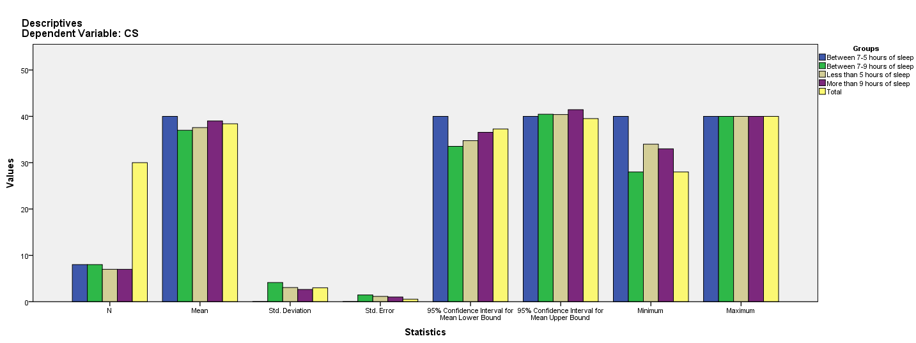

Test of Homogeneity of Variances
CS
Levene Statistic | df1 | df2 | Sig.
5.365 | 3 | 26 | .005

ANOVA
CS
 | Sum of Squares | df | Mean Square | F | Sig.
Between Groups | 43.486 | 3 | 14.495 | 1.731 | .185
Within Groups | 217.714 | 26 | 8.374
Total | 261.200 | 29

Robust Tests of Equality of Means^{b}
CS
 | Statisticª | df1 | df2 | Sig.
Welch | . | . | . | .
a. Asymptotically F distributed.
b. Robust tests of equality of means cannot be performed for CS because at least one group has 0 variance.

Means Plots

